Main Menu:
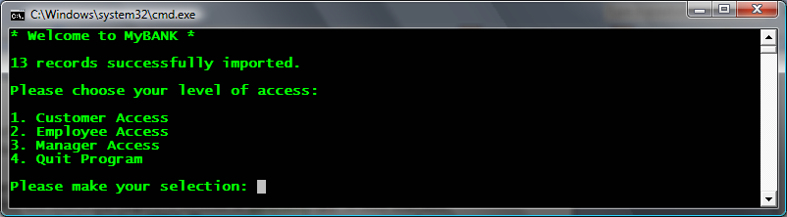

Customer Access Menu:
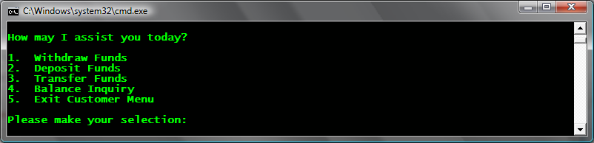

Employee Access Menu:
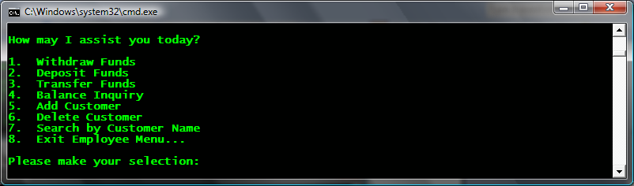

Manager Access Menu:
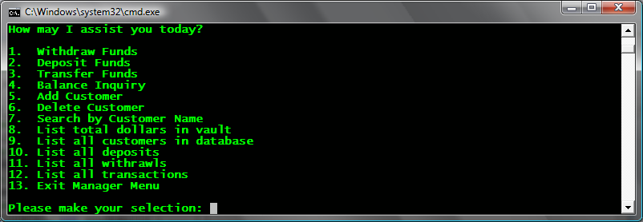
Function – Withdraw Funds
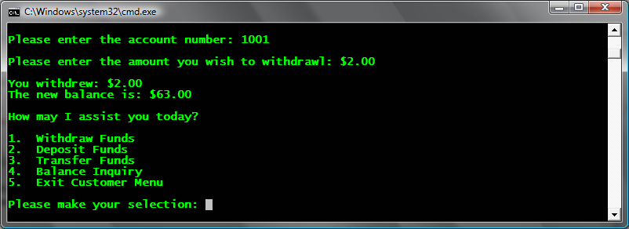
Function – Deposit Funds
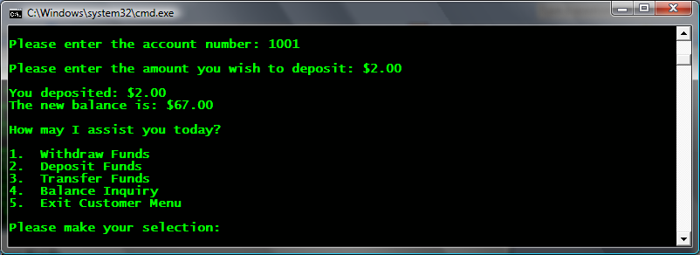
Function – Transfer Funds
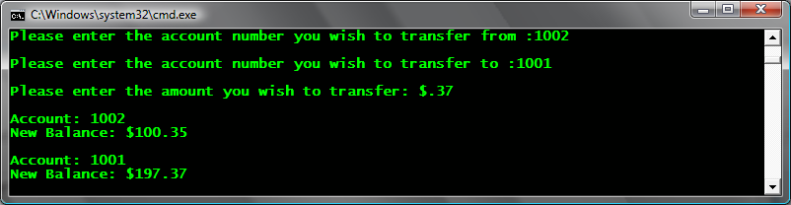
Function – Balance Inquiry
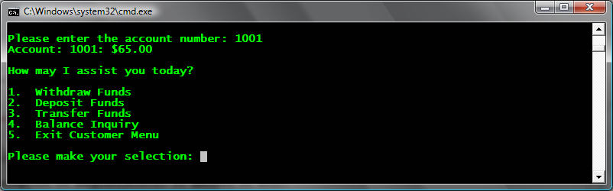
Function – Add Customer
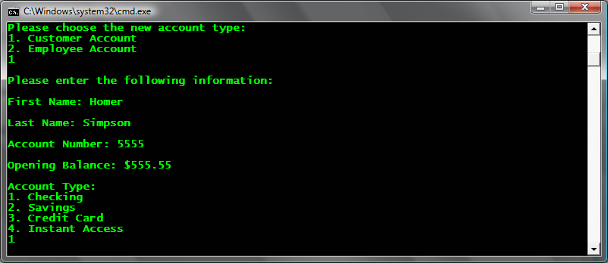

Function – Delete Customer
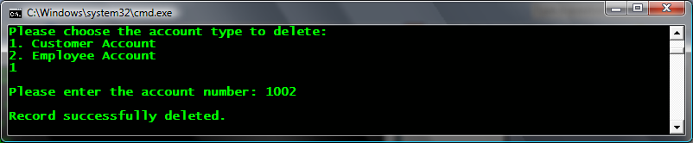

Function – Search by Customer Name
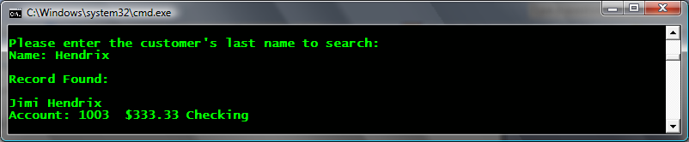
Function – List Vault Balance
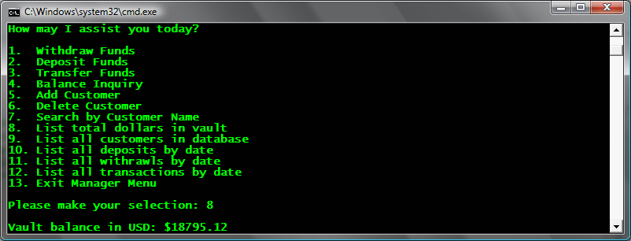
Function – List Customers by Name
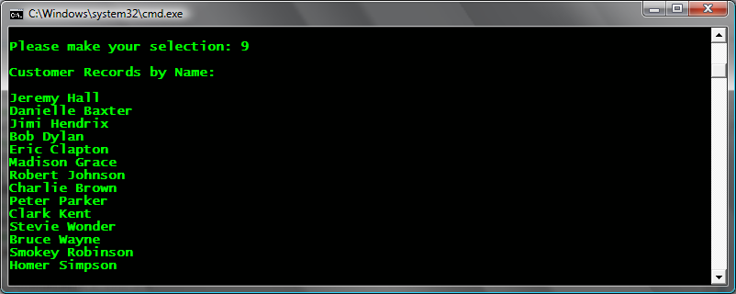
Function – List Deposits
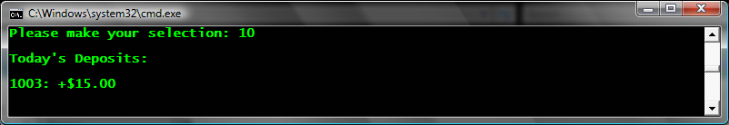
Function – List Withdrawls
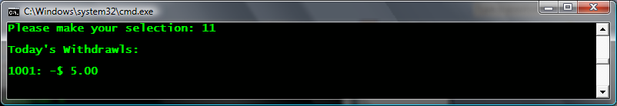
Function – List Transactions
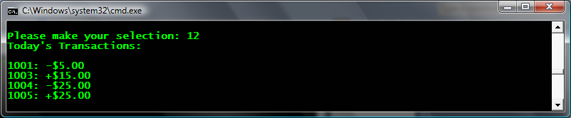
Database.txt
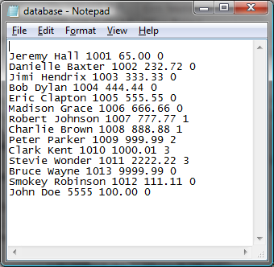
Deposits.txt
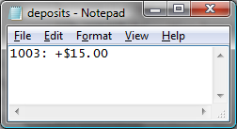
Withdrawls.txt
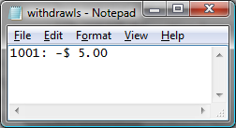
Log.txt
